There is a rent service for music albums and plates. Database scheme is attached.

album
● id
● title
● band

issues (The album can be released multiple times)
● id
● album_id
● release_date

items (Certain discs and plates)
● id
● issue_id

operations (Info about user operations in service)
● id
● user_id
● item_id
● date_start (date of start rent)
● date_end (date of end rent)
● amount (summary of rent in money equivalent)

Write scripts for:

- Find albums that issued more than once

- Show in table % of albums which were rented by 1 or more unique user and % of albums which were rented more then 2 times

- For every user find names of first 2 rented discs

Comments:

Service for creating database scheme: https://app.sqldbm.com/SQLServer/Edit/p225020/#

Site for creating database and test queries: https://sqliteonline.com/

Database scheme
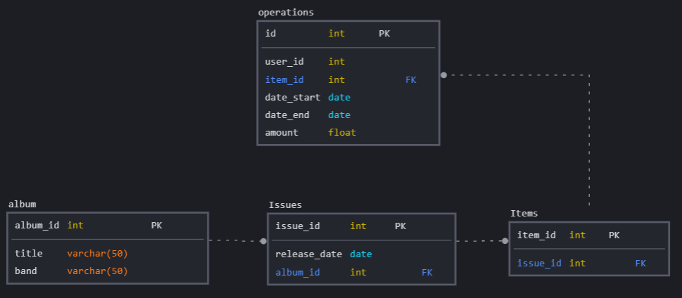

Creation of database

-- ************************************** [album]
CREATE TABLE [album]
(
[album_id] int identity (1, 1) NOT NULL ,
[title] varchar(50) NOT NULL ,
[band] varchar(50) NOT NULL ,

CONSTRAINT [PK_15] PRIMARY KEY ([album_id] ASC)
);

-- ************************************** [Issues]
CREATE TABLE [Issues]
(
[issue_id] int identity (1, 1) NOT NULL ,
[release_date] date NOT NULL ,
[album_id] int NOT NULL ,

CONSTRAINT [PK_9] PRIMARY KEY ([issue_id] ASC),
CONSTRAINT [FK_32] FOREIGN KEY ([album_id]) REFERENCES [album]([album_id])
);

CREATE INDEX [FK_34] ON [Issues]
(
[album_id] ASC
)

-- ************************************** [Items]
CREATE TABLE [Items]
(
[item_id] int identity (1, 1) NOT NULL ,
[issue_id] int NOT NULL ,

CONSTRAINT [PK_5] PRIMARY KEY ([item_id] ASC),
CONSTRAINT [FK_35] FOREIGN KEY ([issue_id]) REFERENCES [Issues]([issue_id])
);

CREATE INDEX [FK_37] ON [Items]
(
[issue_id] ASC
)

-- ************************************** [operations]
CREATE TABLE [operations]
(
[id] int identity (1, 1) NOT NULL ,
[user_id] int NOT NULL ,
[item_id] int NOT NULL ,
[date_start] date NOT NULL ,
[date_end] date NOT NULL ,
[amount] float NOT NULL ,

CONSTRAINT [PK_20] PRIMARY KEY ([id] ASC),
CONSTRAINT [FK_38] FOREIGN KEY ([item_id]) REFERENCES [Items]([item_id])
);

CREATE INDEX [FK_40] ON [operations]
(
[item_id] ASC
)

Filling Database

Insert into album values
('Podruga', 'Gruppa Scryptonite'),
('Maria', 'Gruppa Scryptonite'),
('Ne ver slezam', 'Gruppa Scryptonite'),
('Moskva', 'Gruppa Scryptonite'),
('3 + 3', 'Gruppa Scryptonite'),
('Glypue nenuznue', 'Gruppa Scryptonite'),
('Kosmos', 'Gruppa Scryptonite'),
('Latinskaya myzuka', 'Gruppa Scryptonite'),
('Polozhenie', 'Gruppa Scryptonite'),
('Kosmos', 'The beatles');

Insert into Issues values
('2022-01-01', 1),
('2022-01-05', 1),
('2022-01-07', 1),
('2022-01-10', 2),
('2022-01-13', 2),
('2022-01-15', 4),
('2022-01-17', 4),
('2022-01-22', 5),
('2022-01-22', 6),
('2022-01-25', 7),
('2022-01-27', 8),
('2022-01-30', 9);

Insert into Items values
(1), (1), (2), (2), (4), (5), (5), (6), (7), (9);

Insert into operations values
(1, 1, '2022-02-01', '2022-02-05', 300),
(1, 2, '2022-02-03', '2022-02-08', 500),
(2, 3, '2022-02-05', '2022-02-10', 700),
(3, 4, '2022-02-09', '2022-02-14', 900),
(3, 5, '2022-02-12', '2022-02-17', 1000),
(3, 6, '2022-02-15', '2022-02-20', 1500),
(4, 7, '2022-02-16', '2022-02-21', 1800),
(6, 9, '2022-02-20', '2022-02-25', 1300),
(6, 10, '2022-02-23', '2022-02-26', 2000),
(7, 1, '2022-02-24', '2022-02-28', 1800),
(7, 9, '2022-02-25', '2022-02-26', 800),
(6, 10, '2022-02-27', '2022-02-28', 500);

Queries for database

#1 Find albums that issued more than once.

Select a.album_id, title, band, count(issue_id) as reissues
from Issues iss
JOIN album a ON a.album_id = iss.album_id
group by a.album_id, title, band
Having count(issue_id) > 1

#2 Show in table % of albums which were rented by 1 or more unique user and % of albums which were rented more than 2 times

with cte1 as (select count(album_id) as sum1
FRom operations o
JOIN Items it on it.item_id = o.item_id
JOIN Issues iss ON iss.issue_id = it.issue_id
group by album_id
Having COUNT(distinct user_id) > 1),

cte2 as (select count(album_id) as sum2
FRom operations o
JOIN Items it on it.item_id = o.item_id
JOIN Issues iss ON iss.issue_id = it.issue_id
group by album_id
Having COUNT(it.issue_id) > 1)

select (count(sum1)*100/(select count(album_id) FRom album)), 'Percentage Uniqusers' from cte1
UNION
select (count(sum2)*100/(select count(album_id) FRom album)), 'Percentage Repeated' from cte2;

#3 For every user find names of first 2 rented discs

with cte as
(select dense_rank() over (partition by user_id order by date_start asc) as rank,
user_id, date_start, title, band, a.album_id
FRom operations o
JOIN Items it on it.item_id = o.item_id
JOIN Issues iss ON iss.issue_id = it.issue_id
JOIN album a ON a.album_id = iss.album_id
group by user_id, date_start, title, band, a.album_id)
select * from cte
where rank in (1,2)
order by user_id, date_start

